Dear all,
As the leaves change colour and fall from the trees, they remind us that the seasons change. As we look back and perhaps grieve for a summer that was very different to the one we expected, we now look forward, not knowing what the coming months will bring; one certainty is ‘Immanuel’, God with us, behind us, before us, beside us. With this in mind we can have a fresh hope; hope that we can still be church despite the pandemic, hope that God is working within this new kind of church, perhaps in ways we cannot yet see.
Bishop Libby has written to all of us in the diocese, she too talks of loss and change but also opportunity, renewal and revival.
Bishop Libby writes:
“Thank you for all your patient commitment and faithfulness. As we continue to adjust and adapt to changing circumstances and consequent guidance and legislation, it is understandable that we feel weary and impatient, perhaps. I do appreciate your perseverance. Remaining both diligent and adaptable is hard work over such a long period.
Commitment to innovation and creativity will be necessary, alongside continuing commitment to inherited practice that is faithfully fruitful. Therefore, support through transition, investment in establishing new partnerships and relationships, as well as the re-articulation of continuing models will all need to be in place as people and communities are accompanied through loss, change, opportunity and renewal and revival.
This is a deep work of the Holy Spirit. We will root our work in prayer, and discern the signs of the Kingdom, that we might join in with God, to 'proclaim afresh in this generation the good news of Christ'. Our prayer is that not just what we do, but who we are proclaims that good news.
My desire for this diocese is that we know we are loved beyond measure by Jesus, and sure in the hope that gives us, we have the courage to love without restraint for Jesus' sake. That, for me, is Kingdom of God.
It is an extraordinary grace to be invited to join Kingdom of God. That means for me salvation, community, justice, hope. I don't deserve it; it is pure grace.”

Please pray for our new Curate, Catrin Hubbard as she prepares for her Ordination on Sunday 27th September at 12noon. Catrin has written the following letter to us all:
Catrin writes:
Dear wonderful people of Buxton with Burbage and King Sterndale,
I'd like to take a minute of your time to say thank you so much for making me feel so welcome here after my move a couple of months ago, I can't find the words to tell you how much I appreciate it and thank God for you all.
Thank you also for taking part in the Treasure Hunt and Bible Stones - these have been my first proper tasks in the Parish and the fact that so many people have got involved has been a real encouragement.
As some of you may know, next Sunday (God willing) I'll be ordained as a Deacon in Derby Cathedral at 12pm. The word Deacon translates as Servant - showing that the shape of my work is to serve the people here. It also means that I will have to start calling myself Reverend and wearing a clerical (dog) collar!
Normally the Cathedral would be full for the Ordination Service and followed by
a party with the people in the Parish. Obviously and also sadly, this can't happen this year but if you would like to watch the service please do so following this link (which also includes the link to the Order of Service if you'd like to follow along with the words)
http://derbycathedral.org/.../services/worship-online.html
Thank you all once again and may God bless you in sneaky and beautiful ways, Catrin
Please see the table below for a list of our Parish services over the coming weeks, please note the different times. We will be meeting as a PCC to decide how best to continue to our pattern of worship over the coming months, please pray for good discussions and wise decisions to be made.
27th September | 10:30am | St Mary’s Church
4th October (Harvest) | 11am | St John’s Church
11th October | 10:30am | St Mary’s Church
18th October | 9:30am | Christ Church Burbage
Archdeacon Carol is presiding and preaching on the 4th October at St John’s Church, as Rev Liz has been invited to preach at another Church within the Deanery.
Inevitably, protecting people against coronavirus transmission means our services will look and feel very different for quite some time. Please book in advance if you wish to attend a service, so that the number of people who can attend, whilst maintaining safe social distancing, isn’t exceeded. (Please contact Jennie Parker on 01298 77856 to book in to each service or email with a request, Jennie will confirm with you whether a space is available).

Buxton Team Parish Gift Day
The 3rd October 2020 is Gift day for Buxton Team Parish and we are trying something different this year. Why don’t you do something fun or serious to raise money for our parish and your church? (Or just give a gift if you prefer or sponsor someone else).
All of the above are raising money for all six churches but you can raise money just for your church if you prefer.
This is what you need to do:
- Choose your Church or ‘Buxton Team Parish’ to raise money for.
- Choose what activity you are going to be sponsored for
(See list of suggestions below…)
- Decide whether you need to start before the 3rd October,
or do the activity on the actual gift day.
- Ask friends, family and neighbours to sponsor you.
- You need to get your form and register your idea with Jennie Parker,
in the Parish Office before going ahead.
- Send us photographs of what you are doing or planning so we can share these with others to encourage them (either to Buxton Team Parish Facebook page or email buxtonparish@hotmail.com or phone 01298 77856)
List of ideas for activities: Abseiling, Auction of promises, Baking, Wearing Fancy Dress for x amount of time, (Virtual) Board, Games event, Book Sale, Busking, Car washing, Dance challenge,, Dog walking, Drawing/sketching/caricatures (the kind you see on holiday), Eco fines (people put money in a jar for every time they leave a light on/leave the standby button on/leave taps running etc), Guess the baby photo, Give up crisps/chocolate/alcohol etc for specified amount of time, Hula Hooping, Jewellery making, Knitting, Lawn mowing, Lego making competition, Make & sell jam/chutney, No make up for a week /or allowing small children to do your make up, Online karaoke, Online wine & cheese evening, Paper aeroplane flying, Photography, Plant sale, Running, Shave your head, Shed some pounds, Sponsored cleaning, Sponsored silence, Video game tournament, Videoing yourself doing a dance routine,(chosen by your donors), Virtual pub quiz, Virtual coffee morning, Going veggie/vegan for a specified amount of time, Walkathon, Zoom Quiz, Zoom bingo
These are some of the activities already happening raising money for Buxton Team Parish:
Team Rector Liz is walking around all six BTP churches on Sat 3rd October,
- stopping to pray at each of the churches
Liz Collins is creating a Baby-Photo Quiz of people across the six churches
– can you guess who the baby is?
Curate Catrin is asking for suggestions on what colour to dye her hair
– you pay to vote on the colour
Please support and give money by sponsoring us if you are able, you will receive the list of events and activities by email or you can ask for a letter to be sent to you, or phone Jennie (77856) for more details. You can put sponsorship cash into an envelope with the name of the sponsor and your name through the parish office door or on a collection plate in the church. Or ask someone to pick it up for you if you are shielding.

Phone Up Church Service
All parishioners can phone a local number to hear a service led by the Rector at any time during the week. This call is free or low cost and a new service is recorded each Sunday.
There are 6 options to choose from when you ring in, A Sunday Service, A contemporary worship song and a Traditional Hymn based on the theme of the sermon and Notices for the week.
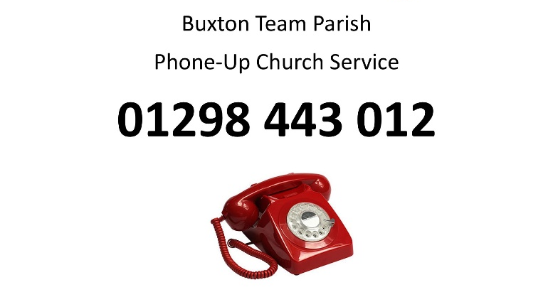
Baby Loss Awareness event – St Mary’s Church
Next month is Baby Loss Awareness Week, this year St Mary’s Church in Buxton will be raising awareness by lighting up the church windows in pink and blue between 9th - 15th October.
We are also creating a remembrance board outside the church for any baby lost in pregnancy or soon after birth. If you would like a name or names added, please email me at BLAWBuxton@yahoo.com. This is a community event to allow us to name, remember and commemorate all the babies lost. So, whether you are the parent, sibling, nibbling, grandparent or family friend we’d love to hear from you.
You don’t have to be from a specific faith or indeed, have any faith at all to take part.
If you would like to join in with
King Sterndale’s Activity Church, contact: lorraine@oldvicarage.org.uk
If you would like to join in with St. Mary’s Jigsaw Church, contact: ericbutterley@btinternet.com
St. Mary’s Sunday Club have been having a ‘virtual Sunday Club’, for resources please contact ericbutterley@btinternet.com.
If you have any prayer requests at this time, please phone Revd Keith (01298 74868)
or email: keithcocking@live.co.uk

Liz England

Blessings to you, Liz England
Team Rector, 24th September 2020

